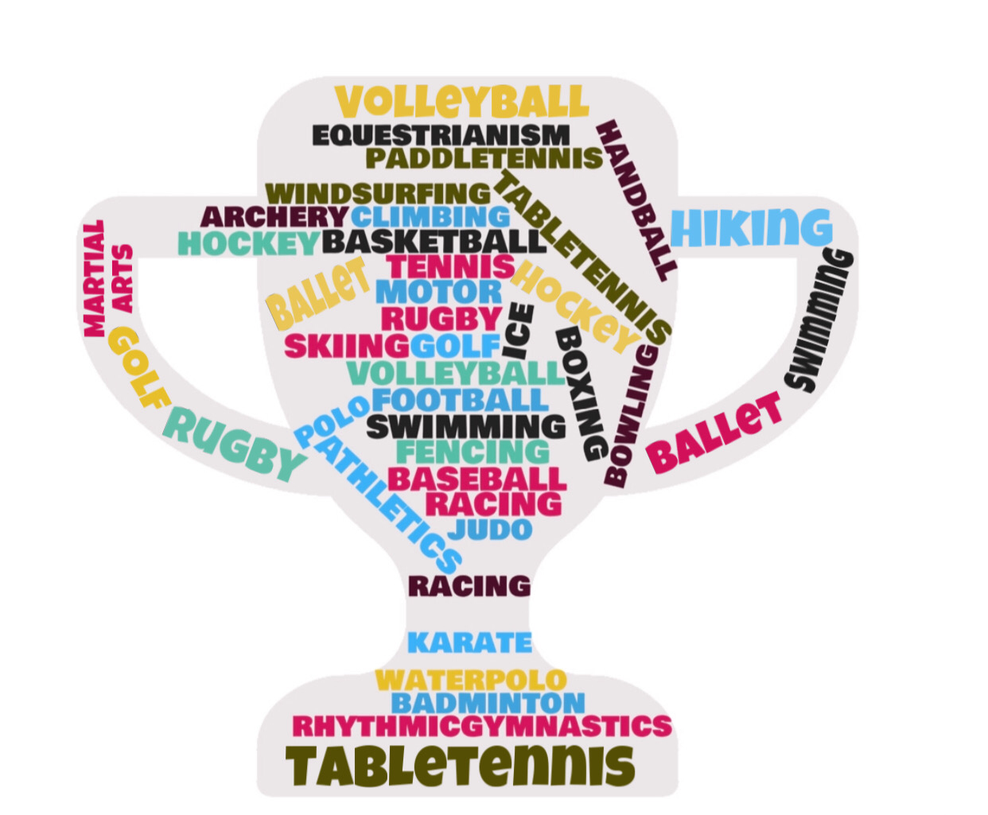
Vocabulary and collocation: SPORTS
ACTIVITY 1: Complete the table with the words of the WordCloud.

PLAY | GO | DO

ACTIVITY 2: Write sentences with adverbs of frequency.

1.____________________________________________________________________________

2.____________________________________________________________________________

3.____________________________________________________________________________

4.____________________________________________________________________________

